**Technical Documentation**

**of the**

**NSSTC e-Library System**

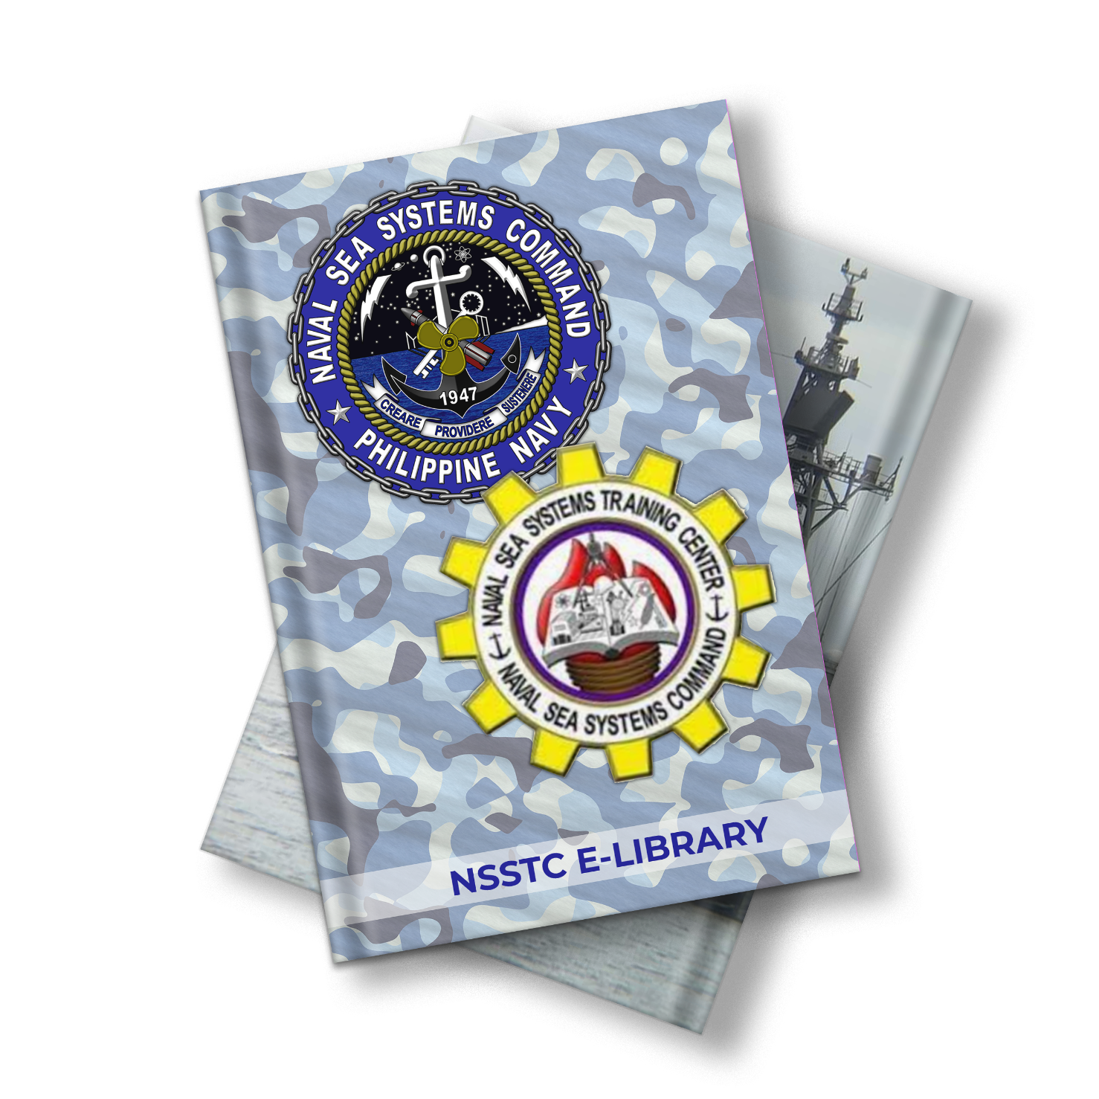

**1. INTRODUCTION 1**

**1.1 PURPOSE 1**

**1.2 SCOPE 2**

**1.3 TECH STACK 2**

**2. CONTROL FLOW DIAGRAM 3**

**3. ENTITY RELATIONSHIP DIAGRAM 4**

**4. DEPENDENCIES & ATTRIBUTIONS 5**

**5. DEPLOYMENT REQUIREMENTS 6**

**1. INTRODUCTION**

**1.1 PURPOSE**

* The purpose of this project is to provide a user-friendly digital platform for managing and accessing a collection of digital references such as e-books, e-journals, videos and other digital materials.
* This project is to provide an efficient information system for various types of references among NSSTC personnel, e-library members, and students.
* This System is a customized digital package designed to be used by Administrators, NSSTC personnel, and e-library members to enhance the user experience of students, researchers, and other library users by providing easy access to digital references in a single platform.
* The system provides a comprehensive search functionality, enabling users to easily search and retrieve relevant information. It also provides tools for managing user accounts, access permissions, and monitoring of e-Library changes such as modifying, adding and deleting outdated references.
* The e-Library System allows librarians to update the references, ensuring that users have access to the most up-to-date information.
* The purpose of this project is to provide a centralized digital repository for storing, organizing, and preserving digital references over time. The system will ensure the integrity and security of the digital collection, providing reliable access to users over the long term.
* The system provides a seamless user experience across devices and platforms, enabling users to access the digital collection from anywhere and on any device. The system will be responsive and optimized for mobile devices, providing a mobile-first experience for users.

### 1.2 SCOPE

1. Scope for managing digital references

The e-Library System will provide a user-friendly digital platform for managing and accessing digital references in the form of the following file types: PDF Document (.PDF) MSWord Document (docx) MS Powerpoint Document(.pptx) and (.mp4) for videos.

The system will allow e-library members and NSSTC personnel to easily search and retrieve relevant information from the digital collection.

The system will support the efficient circulation of digital references by managing user accounts, access permissions, and monitoring changes such as modifying, adding and deleting outdated references.

2. Scope for enhancing the user experience:

The e-Library System will be a customized digital package designed to be used by Administrators, NSSTC personnel, and e-library members to enhance the user experience of students, researchers, and other library users.

The system will provide a comprehensive search functionality that enables users to easily search and retrieve relevant information from the digital collection.

The system will be responsive and optimized for mobile devices, providing a seamless user experience across devices and platforms.

3. Scope for managing the digital repository:

The e-Library System will provide a centralized digital repository for storing, organizing, and preserving digital references over time.

The system will ensure the integrity and security of the digital collection, providing reliable access to users over the long term.

The system will allow librarians to update the digital collection with the latest references, ensuring that users have access to the most up-to-date information.

**1.3 TECHNOLOGY STACK**

This project was built mainly with the following programming languages and technologies:

1. JavaScript

2. PHP

3. HTML

4. CSS

5. MySQL(MariaDB)

**2. CONTROL FLOW DIAGRAM**

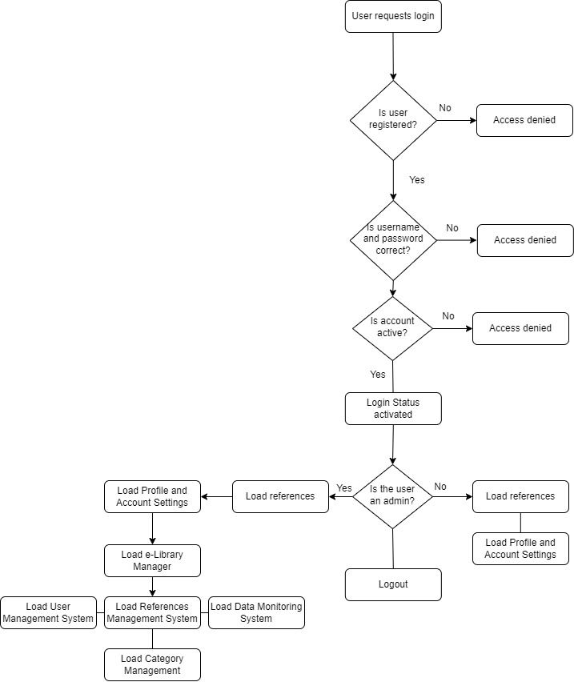

**3. ENTITY RELATIONSHIP DIAGRAM**

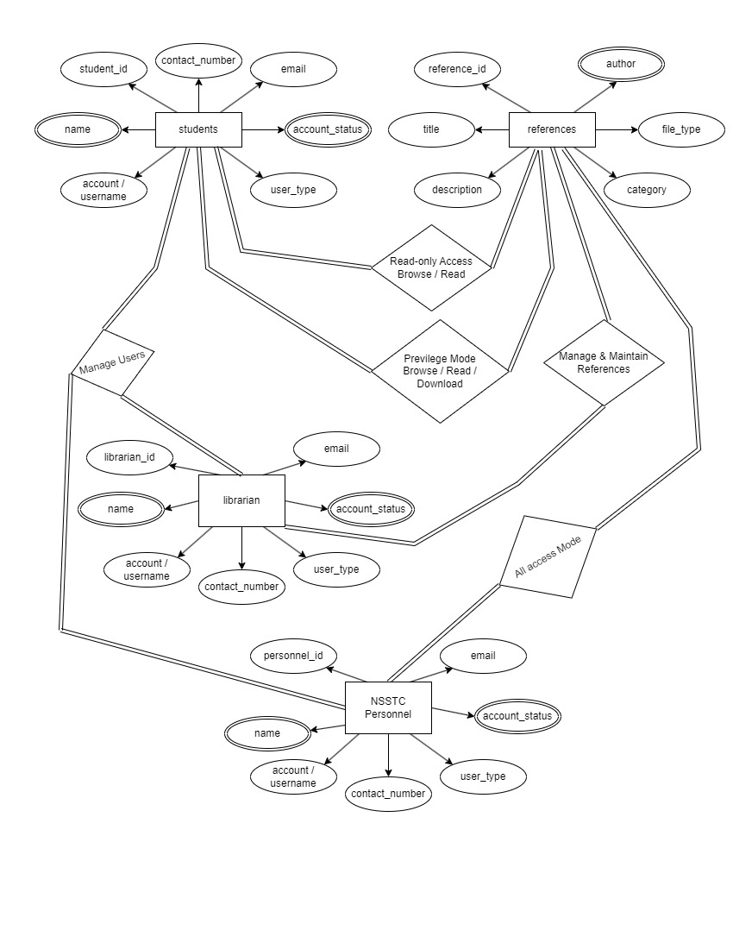

**4. DEPENDENCIES & ATTRIBUTIONS TO OPENSOURCE SYSTEMS**

A software dependency is a relationship between software components where one component relies on the other to work properly. For example, if a software application uses a library to query a database, the application depends on that library.

1. Bootstrap Components – Few of the components such as button stylings are online dependent on the content delivery network of getbootstrap.com, but the system will still run with 100% operational capacity if deployed on an offline local server, local area network or intranet network environment.

2. Adminmart.com – This online platform offers UI components for free and some UI components for this system are derived from adminmart.com with proper attribution already included within the software package of the system as required by adminmart.com. The UI components have already been downloaded within the system and will allow the system to be fully functional if deployed in an offline local server, local area network, or intranet network environment.

3. font-awesome.com – This online platform offers UI components especially the icons for free and some of its icons were used here with proper attribution as required.

**5. DEPLOYMENT REQUIREMENTS RECOMMENDATIONS**

* **Web Server: Apache (Already included in the admin panel for most hosting platforms)**

Apache is the most popular web server and is compatible with any operating system, whether Linux, Mac or Windows. Apache is known for its stability, flexibility, and compatibility with various operating systems. It supports PHP out of the box and offers features like URL rewriting, SSL/TLS encryption, virtual hosting, and more.

* PHP Interpreter: (Already included in the admin panel for most hosting platforms)

Install a PHP interpreter on your server. The specific version depends on your application's requirements, but it's recommended to use the latest stable version of PHP. Ensure that the necessary PHP modules/extensions are also installed, such as the MySQLi extension for connecting to MariaDB.

* MariaDB (MySQL) Database Server: (Already included in the admin panel for most hosting platforms)

Install and configure the MariaDB server on your server. Make sure you have the appropriate version of MariaDB that is compatible with your PHP version.

* Database Management Tool: (Already included in the admin panel for most hosting platforms)

You may also want to install a database management tool such as phpMyAdmin to help manage your MariaDB database. It provides a graphical interface to interact with the database.

* Operating System: PHP and MariaDB are compatible with various operating systems, including Windows, Linux, and macOS. Choose an operating system that best suits your needs and ensure that it meets the system requirements of PHP and MariaDB.
* Using XAMMP this system can be deployed in the most simple local area network without a dedicated server. The system can be installed on any computer preferably with higher specs provided that a static I.P. for that computer is setup and that I.P. address must be reserved only to be used by that server so that other computers can always communicate with it.